Mobile Technology and Consumer Empowerment: an Application for Consumer Mediation in Catalonia (Geoconsum)

ABSTRACT
Consumer mediation is widely used in Catalonia. However, it has not yet achieved its full potential, partly due to the lack of consumer awareness of ADR means. In this regard, mobile technologies may help provide efficient information to consumers, and bring consumer mediation entities closer to consumers. Geoconsum is an open source mobile application that has been devised with the aim of contributing to empower consumers in Catalonia. This article shows the conceptual framework of this application. It presents the methodology and the process of implementing this application, from the initial design and population of the databases (which encompass a consumer mediation entities database and a compendium of consumer legislation applicable in Catalonia) to the implementation of the mobile application that end-users may install in their smartphones. This article also addresses some challenges that have been found in order to create those databases. Furthermore, it shows the mobile application functionalities and the search and retrieval capabilities, based on parameterised searches as well as on geolocation technology. The device also works as a mapping service application since it offers a route planner to access the nearest consumer mediation entity.

Keywords: consumers, mediation, Alternative Dispute Resolution (ADR) Online Dispute Resolution (ODR), legal databases, Consumer Law, mobile applications

- Introduction: Dispute resolution and consumer empowerment
In 2011, the Catalan Consumer Agency handled almost 14,000 complaints. Consumers buy products and services and most of the times they are satisfied with those products or services. In some occasions, though, consumers experience problems with a transaction and may enter into the sphere of conflict. When that happens, consumers do not access formal sources of legal aid; specifically do not access courts. It is well known that court proceedings entail some complexities and costs that make this sort of access to justice unbearable for consumers. Alternative Dispute Resolution (ADR) and Online Dispute Resolution (ODR) means such as mediation and arbitration, remain as sources of consumer redress. In Spain, the Consumer Arbitration Scheme sets up a mediation procedure as the first and previous phase that parties may try before the dispute escalates into an institutional consumer arbitration process. The White Book on Mediation in Catalonia (WBMC) has shown that mediation has gained a conceptual and practical independence from arbitration over the past years. Mediation, as a consensual method of dispute resolution, appears to be particularly suitable to manage and solve consumer disputes.
A mediation process is a structured process characterised by the intervention of an impartial third person who aims at assisting the parties while both of them retain the control of the process, and makes it easier for them to obtain a satisfactory agreement by themselves. The mediator does not impose or propose a solution to the parties; he puts his efforts in bringing the parties together so that they can find a common solution. This structured process is governed by some principles such as those enshrined in the Consumer Code in Catalonia, namely of voluntary participation and self determination, impartiality, confidentiality and universality. Moreover, other principles could apply such as the principle of transparency, effectiveness and fairness. In the online environment, a mediation undertaken by a public body must follow some principles of the e-Administration such as the principles of interoperability and information security.
In Catalonia, there are several public entities offering consumer mediation services, considered as consumer public services by the Consumer Code. These entities include the local (OMICs) and supra local (OCICs) consumer information offices, the Catalan Arbitration Consumer Boards, the European Unit at the Catalan Consumer Agency and the local Arbitration Consumer Boards. In addition, private bodies such as consumer organisations also provide mediation services to their members. Only in 2008, there were more than thirty thousand consumer mediation services in the field.
Nevertheless, mediation and other ADR means have not yet achieved its full potential. According to European surveys, only 3% of Europeans whose complaint with the seller or provider was resolved unsatisfactorily brings the matter to an arbitration, mediation or conciliation body. Consumer awareness of ADR methods is very limited; consumers neither have an easy access to detailed information on ADR procedures, nor have information about the use, the number of cases and the past performance of the ADR scheme. Moreover, Spanish consumers are almost at the bottom of Europe as regards the knowledge of consumer associations and public agencies: more than 50% of Spanish consumers do not know any public authority or consumer organisations. Consequently, the lack of consumer awareness of these means of redress is still a barrier that needs to be overcome.
In fact, the European institutions have linked the empowerment of consumers to the provision of information to consumers as well as to their capability to seek redress when necessary. In this regard, the EU Consumer Policy Strategy 2007-2013 believes that with the empowerment, “consumers make optimal decisions, by understanding their own preferences and the choices available to them. They know their rights, recognise when these have been breached and if so, complain and seek redress when necessary.”
In this scenario, the provision of information takes a leading role in order to enhance consumer protection. For years, Consumer Law has introduced the provision of information in order to counterbalance the relations between consumers and traders, and therefore, to protect consumers. Traditionally, it has been understood that consumers have less information than traders. As a result, consumers have difficulties in making realistic expectations and decisions that reflect their preferences, which it may increase harm. Although that may be questionable for active and better-informed prosumers, the previous statement may be still true as for middle class consumers. Furthermore, European Law has a preference for information-based protection since this imposes fewer barriers to free movement than substantive regulation. The provision of consumer information has been considered as a win-win solution: consumers are given the means to protect themselves whilst restrictive regulatory controls are avoided on business. However, it has also been suggested that consumers may not always respond to information provided as rationally as it may be assumed. For one thing, few consumers take notice of information provided due to lack of time. Moreover, those who take advantage of information are likely to be the more affluent, well-educated middle class consumers. Consequently, the way information rules are framed would need to be revisited alongside with a strategy of information provision.
2. Objectives
This work aims at presenting the research undertaken in order to design, populate and implement two databases in the consumer field in Catalonia. It also presents the mobile application that contains those databases and that end-users may install in their smartphones. Geoconsum has been conceived as a mobile device that may bring consumer protection entities closer to consumers. This tool may be of assistance before the conflict begins, as a tool for dispute avoidance or dispute prevention, and especially when the conflict has already started. When this happens, Geoconsum may provide an immediate contact tool with consumer mediation entities.
In the following lines this article shows the specific work undertaken as regards the databases and the mobile application, and it offers a conceptual framework for Geoconsum. Further to section 1 that introduces consumer empowerment and ADR means, section 3 addresses some issues concerning legal information databases. Then, section 4 focuses on the consumer mediation entities and consumer legislation databases. Section 4.1 addresses the methodology employed to elaborate the databases whereas section 4.2 exposes some challenges that have had to be solved. Section 4.3 addresses the content of those databases and provides some quantitative data. Then, section 5 focuses on the mobile application and its functionalities. Finally, Section 6 points out some conclusions.
The research undertook with Geoconsum follows a line of research at the crossroads of Law and technology in the consumer domain which aim at analysing and implementing relational justice means, specifically mediation for consumers. For instance, the Consumedia project aims at implementing an online dispute resolution platform. Moreover, the Ontomedia projects aimed at providing a semantic platform whose bus of services would facilitate a better access to justice through mediation. Furthermore, the White Book on Mediation in Catalonia (WBMC) was aimed at both analyzing mediation activities and needs in Catalonia, as well as fostering mediation throughout the territory in its several domains of scope. In particular, the consumer chapter of the White Book represents a deep and systematic approach and analysis of real data consumer mediation. Chapter sixteen of the WBMC is devoted to study the uses of technology in mediation services and proposes some recommendations such as the promotion and implementation of ODR, particularly in the consumer domain.
3. Legal information databases
The free access to law movement represented under the World Legal Information Institute (World LII) celebrates this year the 20th anniversary of the first legal information institute. The application being dealt here with, Geoconsum, conforms with the main principles of the Free Access to Law Movement enshrined by the Montreal Declaration. This Declaration considers that public legal information “is digital common property and should be accessible to all on a non-profit basis and free of charge”. It also promotes and supports “free access to public legal information throughout the world, principally via the Internet” and recognizes the “primary role of local initiatives in free access publishing of their own national legal information.” In fact, as it has been put up, “the LII Movement is a basis for a major worldwide transformation in access to justice for lawyers and general public.” Moreover, as regards the public sector information (PSI), Directive 2003/98/EC promotes the re-use of official texts of legislation and other administrative documents.
Nowadays, there are many open areas of research in online legal information services and in legal information retrieval. One of these areas relates to the degree of usability of online legal information services. Particularly important are several projects and studies which have dealt with the degree of usability of legal databases as to non-lawyers. For instance, the Add-Wijzer project was set up to investigate ways to improve access to Law and to improve the usage of law information by business professionals who are not trained in law. Some literature has studied the end-user acceptance and willingness to online information systems, in particular when end-users are not experts in Law. Here, the relevance of domain expertise and expert mental grouping has been studied. Other scholars have supported the effects of expertise on information retrieval with implications for the design of systems to support the use of information. According to the former studies, professionals not trained in Law find current online legal databases difficult to use, at least they find them harder than legal experts. There are, however, other areas of research in information systems: for instance, a European project developed into a Legal Atlas where normative texts and geo-information were represented on maps. Accordingly, the importance of visualization of legal information has been highlighted.
Additionally, private legal information companies are putting most of their efforts in developing truly semantic search engines, in order to enable users to conduct research using natural language. In this area, it could be said that many scientists are today putting their efforts in closing what R. Susskind names the technological lag. According to R. Susskind:
“Data processing is our use of technology to capture, distribute, reproduce, and disseminate information. We have become extremely adept at this. (...) But now, knowledge processing is coming to the rescue. This is a set of technologies that helps us analyse, sift through, and sort out the mountains of data that we have created and helps make them more manageable. Data processing has advanced well ahead of knowledge processing, but the gap between the two, the technology lag, is going to close. When it closes, we will be fully in the information society”
Furthermore, some legal databases are being built up with crowdsourcing efforts. To name only one example, the Constitution Database organised by the Stanford University tries to tag national constitutions of the world, by theme. Thanks to the tagging task of many students, a set of categories will feed a constitutions’ database, which will enable people to compare other countries’ constitutions.
- Consumer Databases in Geoconsum
  - Methodology for the database elaboration
The research for setting up the content of the database was initiated in 2010 and finished in July 2011. As to the input information, this was manually searched for, extracted and classified from a variety of resources, encompassing legal web search engines as well as specialized resources by consumer protection agencies and associations. The Spanish Consumer National Institute, Cidoc’s database, has proved to be one of the most trustful sources of information on consumer topics in Spain. In addition, some of the consumer regional bodies display some information on the matter, although their relevance varies a great deal between their web pages. For one thing, the Catalan Consumer Agency shows a large database of consumer legislation applicable in Catalonia, even though some outdated legislation acts have been found therein. The civil legislation compendium ran by the Institute of European and Comparative Civil Law at the University of Girona has also been of assistance. Another source of information may be attributed to several consumer associations spread over the Spanish territory such as the Organización de consumidores o usuarios, Facua-Consumidores en acción or the Unión de Consumidores de España – UCE, to name only a few. Beyond these institutional approaches and those of consumer organisations, there are other private projects built on a collaborative basis that have received great interest of citizens, such as those of the webpage consumoteca.com.
The initial steps of the database research period identified two main subdomains. On the one hand, the application would have to be a receipt of normative instruments applicable to consumers in Catalonia. For research purposes it was decided that normative instruments would be differentiated according to its binding and non-binding nature (identifying hard and soft law instruments, respectively). Moreover, according to the Spanish distribution of competences between the central State and the Autonomous Communities (regions) in the consumer domain, a further classification was adopted as to identify Spanish, national normative instruments and Catalan normative instruments.
On the other hand, the second subdomain was related to consumer entities providing consumer mediation services. Chapter 5 of the WBMC showed that there is currently a wide array of public and private entities providing different kinds of services to consumers, ranging from information to mediation and arbitration services. Therefore, the database would provide a user-friendly and efficient way to access all those entities that are spread out in the territory.
A Google document was used to manually build up the database information. This process encompassed a selection of Catalan consumer legislation. It also included information and contact details such as addresses, web pages, email contacts and telephone numbers of different consumer mediation bodies such as the Catalan Arbitration Consumer Board, its delegations and the Arbitration Consumer Boards. The document also included local consumer information offices (OMICs) and supra local consumer information offices (OCICs). Moreover, information and contact details of private consumer associations were also included. Finally, there was a miscellaneous column about other relevant issues. Another “Google docs” document was used with the aim of covering national legislation and information covering the whole territory of Spain. Finally, another document identified instruments of European consumer legislation.
  - Challenges faced in the process of implementing the database
    - Challenges in the legislation set
As regards the legislation set implementation, some challenges were faced. The first and main concern was of a conceptual nature and was related to the concept of Consumer Law or, in other words, to the question of how many acts covering how many areas should be included in the database. Indeed, “it is not possible neither even of use to work on a precise delimitation of Consumer Law (...) Legal disciplines such as Consumer Law do not have clear-cut borders drawn in straight lines,” as Calais-Auloy and Temple have put it. In particular, the boundaries of Consumer Law may go beyond the private scene and enter into other branches of Law, including public or administrative spheres. There are already some compilations of Catalan and Spanish Consumer Law, and although they are not up-to-date, they have been of use as to determining the scope of the database.
A narrow or core concept of Consumer Law encompasses two cumulative requirements: legal rules that are defined by the relationship between traders and consumers, and rules that are enshrined by their consumer-protecting element, that is, rules that are devoted to counterbalance the disproportion between those actors. This approach has been followed in order to build up the database. Moreover, Consumer Law may also be extended to some rules that are mainly, even if not exclusively, applicable to consumers. Therefore, the database includes additional normative acts such as instruments that, even if they are conceived of a general application, they are mainly applicable to the Business to Consumer (B2C) relationship (such as liability for defective products, leasing or warranties). In the database, other general instruments that may affect consumers such as jurisdiction rules or contract non-performances have been omitted as well as instruments governing specific products or services (alimentary, pharmaceutical, insurances, etc). Furthermore, there are other normative instruments that have been included according to their specific relevance. For instance, since air transport claims represent more than 63% of the total of cross-border complaints in Catalonia, EC Regulations on air transport have been included. Moreover, some normative rules on data protection have also been included.
EU Consumer Law has had a fundamental importance in the creation and development of Consumer Law throughout Europe. The Single European Act of 1986 introduced consumer protection laws in Europe with the aim of harmonising consumer protection policies; ever since Member States have been due to transpose into their legislations a broad variety of EC Directives, most of them entitling Member States to adopt more restrictive and protecting rules in their countries. As a result, Consumer Law in Europe has become a fragmentised area, even though the EC Directive on consumer rights has tried to clarify this scenario. Therefore, the inclusion of EC norms in the database has been considered as necessary. Well-established principles of EC Law such as the principle of primacy of EC Law or the duty for national courts of interpretation of national Law in conformity with EC Law indicate that national consumer laws must always have a look at European Law.
Moreover, Consumer Law is made up by mandatory rules that impose rights and obligations to consumers and traders. In addition, this field is also affected by different instruments of self-regulation and co-regulation such as codes of conduct, guidelines, good practices and other soft law instruments. Some of these instruments are included in the database.
In Catalonia, the Catalan legislative and executive bodies have exclusive powers in matters of consumer affairs. However, the central State has also exclusive powers in some matters related to consumer affairs. As a consequence, the consumer domain in Spain represents a crossroad of centralized and decentralized levels of legislation. As regards the database elaboration, two different documents were built up including Spanish and Catalan consumer legislation. The first document covered national normative acts promulgated by the central legislative or executive powers. The second document covered normative acts promulgated by the Catalan legislative or executive powers.
Another challenge to be faced when implementing the database was connected with the difficulty to determine only existing legal instruments in the field. In fact, since Consumer Law has had an extraordinary and chaotic development, getting to know those acts is not an easy task: further to the different levels of legislative jurisdiction (European, State and Autonomous Communities), legislation in this field varies considerably and may suffer quite often several changes. Thus, as concerns the activities undertaken in the legislation subdomain, a revising phase was undertaken in order to introduce current normative instruments and discard repealed instruments.
    - Challenges in the consumer mediation entities set
One of the main challenges of creating a consumer mediation bodies’ database in Catalonia has been their heteronomy and dispersion throughout the territory.
In addition, the treatment of information has been manually done. Trying to put all this information together, classifying it and having contact details of all these bodies and institutions has been a demanding task. At the beginning of the research process, several students of the Faculty of Law at the Autonomous University of Barcelona collected some of this information. Thus, the different types of entities are classified and stored in the database which contains contact information such as addresses, emails, telephones and web pages. Moreover, the longitude and latitude of those entities (GPS position) is also stored.
  - Database Content
    - Content in the legislation set
The overall amount of legislation displayed in the database includes a total of one hundred and twenty-one legislative acts, twenty-eight acts of European nature, forty-five acts from the legislative and executive powers in Catalonia and forty-eight national instruments.
Figure 3. Levels of legislation included in the database

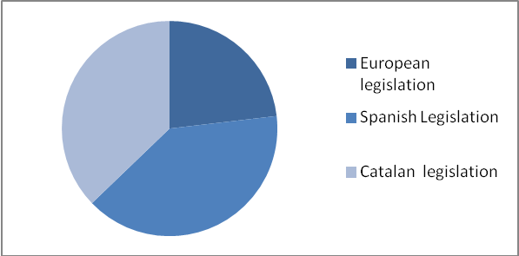
Source: Own elaboration.
The database includes one hundred and ten binding normative instruments and eleven non-binding instruments. As for the first category, at European level twenty EC Directives and six EC Regulations are included. Moreover, there are forty-five Acts, fifteen Royal Decrees, nineteen Decrees and two Legislative Decrees. There are also three Ministerial Orders. As for the non-binding instruments, the database finally reports eight Codes of Conduct and three Recommendations. This information is shown in Figure 4.
Figure 4. Number and type of normative instruments included in Geoconsum.
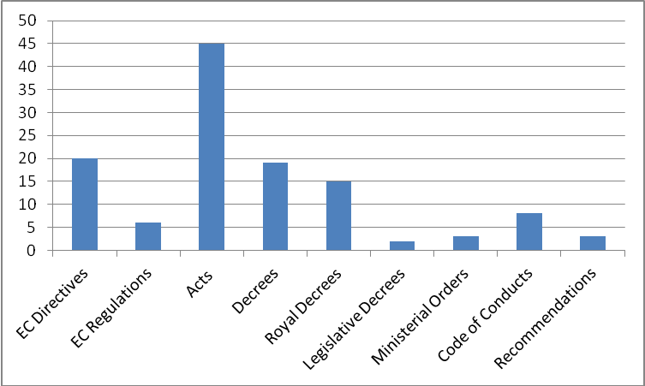
Source: Own elaboration

  - Content in the consumer mediation entities set
As regards the subdomain on consumer entities, the database contains details about a hundred and forty-nine consumer mediation bodies. This number includes one hundred and three public and local (OMICs) and supra-local (OCICs) bodies of consumer mediation. It also includes fourteen arbitration boards which encompass the Catalan Consumer Arbitration Board as a public entity dependent on the Catalan Consumer Board and the local Arbitration Boards. Finally, the database provides information and contact details of thirty-two consumer associations in Catalonia. In total, the database provides contact details of consumer protection bodies in ninety-six cities, towns and villages.
Figure 5 reports the total number of entities included in the database and its classification
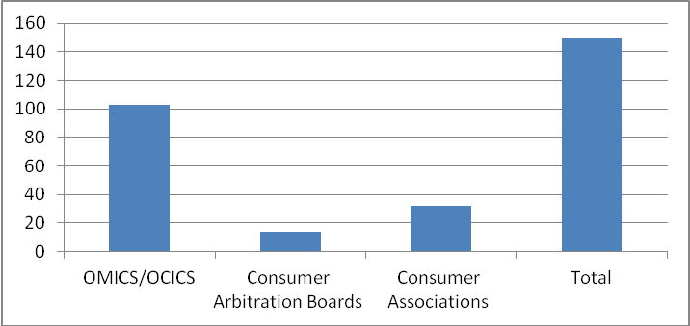
Source: Own elaboration
- The mobile app and its functionalities
  - Mobile app
Today, there is a need to a better access to public sector information (PSI). Access to PSI includes the design of better tools to make such access possible, which in turn may help professionals in their tasks and non-professionals in their demand for public information. In order to design public sector information tools, the importance of visualization of legal information has been highlighted. Moreover, the consumer domain seems to be a particularly suitable arena for implementing technological devices. In particular, the Internet, as a new channel, may assist consumers in legal problem solving.
Mobile devices are particularly suitable and appropriate tools for providing information on consumer mediation entities and legislation. Mobiles are portable, durable, basic and relatively low-cost. They also employ easy-to-use technology and have far-reaching functionalities. Indeed, mobile penetration has grown incredibly over the past decade, and it seems that services attached to mobiles dispositions will increase accordingly: only in 2010 mobile broadband, as measured by the number of data cards, grew 71% in Spain. In addition, some striking information foresees that mobile phones could outnumber humans by the end of 2012.
Geoconsum has been designed by implementing a user-friendly interface with basic and appropriate technologies. The application is devised to Android OS devices, although it will be later implemented in other operative systems, such as Windows Phone and IOS (Apple). It is important to note that the software code is published open source, so that any consumer entity can take advantage of it and use it to build other tools customized to their needs.
The application incorporates sensors that smartphones usually use. For one thing, it has a GPS (Global Positioning System) sensor that provides location awareness functionalities. Accordingly, end-users may be routed to the nearest consumer protection offices. Furthermore, Geoconsum runs as a standalone application. This means that some components of the client interface, such as screens and forms, are not sent from the server platform to the interface in every interaction. Moreover, some user data can be stored into the smartphone memory. These features are important in mobile devices to save battery and bandwidth usage.
It is worth taking into account that Geoconsum has been implemented in a research centre devoted to study the intersections between Law and Technology. It has neither been developed from a commercial enterprise nor is it directed to be addressed to a for-profit business. Accordingly, end-users may download this application free of cost to their smartphones or tablet computers from the research centre’s web page as well as from the Google Play Store.
Geoconsum represents a modest approach to information systems. It does not contain a semantic tool which could improve the search and retrieval functions. Indeed, this functionality would be important since it would allow the application to extract the concept of the search performed by the end-users. However, this functionality is left for further research and later updates of the application. Moreover, a further study of the end-users’ usability could be also profitable. As the application may be used by consumers, the legal information set could be developed in order to enable end-users not only access the law but also help them understand it. However, further resources would be needed. In fact, a future development of Geoconsum could be directed towards the integration into the Consumedia project, which is due to implement an online dispute resolution platform. This integration could allow the management of electronic complaints or the assessment of the mediation process. Moreover, it could develop other interesting functions: for instance, the location of the conflict could be stored in the smartphone, or the user could take a picture of the product involved in the complaint and store it in the conflict management tool.
  - Geoconsum functionalities
The interface is a search form designed in a user-friendly way that can initiate a search and generate results both of i) consumer mediation entities, and, of ii) consumer legislation.
As for the entities subdomain, the application shows results either by a geolocation tool or by an advanced search based on preset parameters. In the first case, the application displays a list of the nearest consumer entities through a GPS. The proximity parameter shows a 10 km’s distance, although users are able to modify this parameter. Once the end-user clicks on one of the offices, the application initiates a Google Maps API in order to display a route planner to the entity searched for. The application also enables consumers to search between some parameterised data such as the type of consumer entity. For one thing, the end-user may be willing to search for only a particular type of consumer entity or may prefer to have all the entities displayed. Moreover, the parameterised search can also be done by the location parameter. Consequently, Geoconsum may initiate a general search of entities operating in Catalonia or initiate a more precise search of entities in a particular province, city or village.
Once the end-user has chosen a specific entity, the application displays its different contact details. The end-user may click on a particular item such as the telephone number, the electronic mail, the website or the localisation request on the map. Consequently, the application is capable of doing the corresponding action; that is initiating a phone call or opening an email form which can be sent to the entity’s electronic recipient. It can also access the entity website by opening a link in a web browser or seeing its localisation in Google Maps. Based on GPS parameters, the application calculates the distance to the nearest entities and it offers a route planner to the chosen one.
Figure 1. Search of consumer mediation entities in Geoconsum.
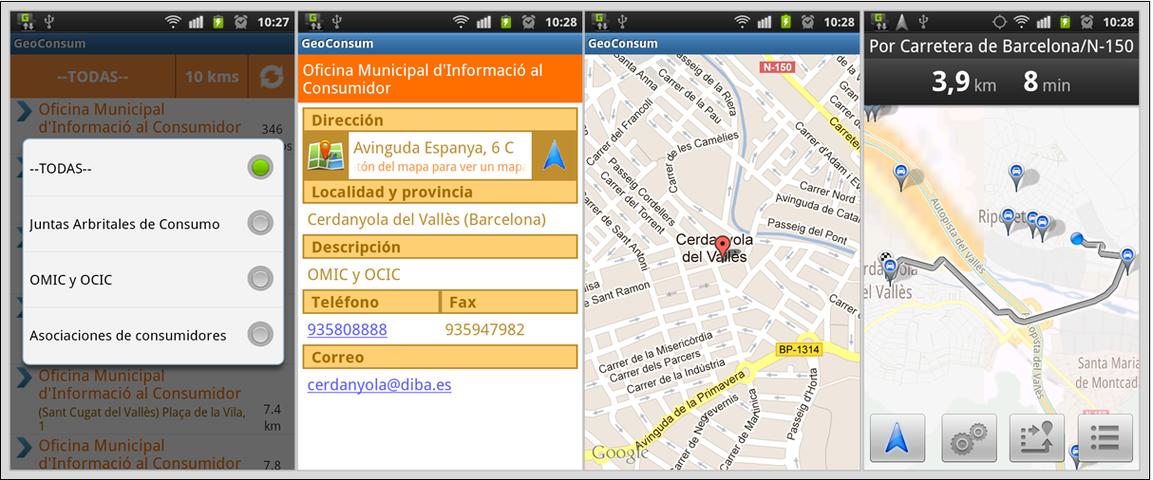
Source: Own elaboration
The application also informs consumers about the fact that they should first claim to the provider of the goods or services, and only address the consumer mediation service once the claim with the enterprise has not been resolved satisfactorily. In addition, the application informs that consumers should address to the consumer public service of their domicile; and if there is no office in their domicile, they should address to the competent supra-local office.
As regards the legislation subdomain, there are different search and retrieval options. First, the application implements a search by queries. End-users can perform a search by using key words in text or by audio. Therefore, if a consumer asks for acts regarding a particular key word, such as the consumer arbitration scheme, then normative instruments regulating that topic will be displayed. Moreover, the app has an advanced search, where end-users can perform a search by parameterised data. This advanced search includes the search by the level of legislation (European, Spanish, Catalan), according to its binding and non-binding nature, or according to its type of rules (such as Acts, Decrees, Ministerial Order etc). Therefore, the parameterised search enables consumers to search and retrieve the full text of a particular normative instrument searched for. This option may help end-users that either do not know the content of the Law or are aware of a particular type of legislation and want to consult it.
Figure 2. Geoconsum legislation search
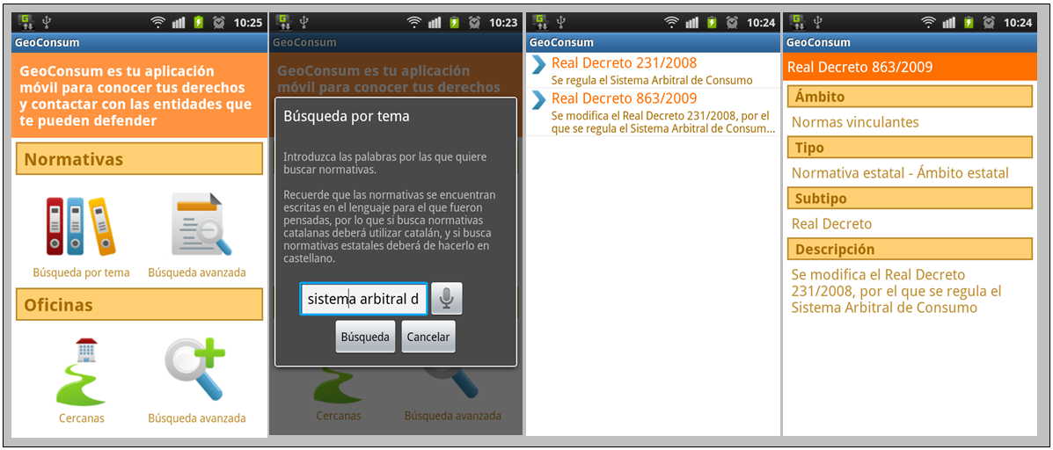
Source: own elaboration

- Conclusions
In the consumer domain, the lack of awareness of the consumer redress methods represents one major drawback. Consumers do not appear to be well informed about existing ADR systems such as mediation. In addition, some consumer surveys show that this situation turns to a lack of trust. Therefore, consumers do not fully benefit from the existing methods and systems of ADR. In this regard, European institutions are devoted to tackle these drawbacks by empowering consumers. Policies on consumer empowerment imply that the provision of information is of a vital importance so that consumers can defend themselves and seek redress when necessary.
This work has presented a database and a mobile application (Geoconsum) which hopes to contribute to the empowerment of Catalan consumers in this field. The database has been devised as two-fold: first, it offers information and full contact details regarding consumer mediation bodies. In short, a wide and heterogeneous list of consumer mediation entities from both the public and private sphere is presented. In total, the database provides details of a hundred and forty-nine consumer mediation entities covering ninety-six Catalan villages, towns and cities. Second, it also offers a search and full text retrieval option for legislation in Catalonia, encompassing legislation from the European Union, Spanish normative instruments, and normative instruments from the Catalan legislative and executive powers. A conceptual exercise of what Consumer Law is and what normative acts Consumer Law should encompass has been done before implementing the database. In total, Geoconsum offers a hundred and ten binding instruments and eleven non-binding instruments in the scope of Consumer Law.
The information contained in the database is offered to end-users through a mobile application. Indeed, mobile penetration has had a tremendous increase worldwide, and mobile devices are portable, durable, basic, and relatively low-cost. In addition, they are well adapted to employ easy-to-use technology, and are capable of using different applications on the go. In this regard, mobiles are appropriate and efficient tools for offering consumer information.
Geoconsum has been implemented as a user-friendly tool, a familiar application to consumers. Overall, the end-users’ needs have been kept in mind. Thus, Geoconsum has been developed as an appropriate and efficient tool. Moreover, the software code is open source, so consumer entities may freely use it or customise it to their needs. Moreover, it is easily scalable to other EU countries and other consumer bodies.
This is the first version of the application and further updates may be required. It would be particularly important to put efforts to improve the semantic capabilities of the search and retrieval functions. Additionally, helping consumers understand and make use of the returned legal documents remain as another interesting line of research. Nevertheless, it is currently believed that beyond complex software engines, a basic and easy-to-use mobile application which consumers can download into their mobile devices may contribute, modestly enough, for a better access to justice for consumers.

Josep Suquet-Capdevila is a researcher at the Institute of Law and Technology (Universitat Autònoma de Barcelona), Spain. Josep.Suquet@uab.cat
From 2011 to 2012 consumer complaints handled by the Catalan Consumer Agency (CCA) have decreased (11%). From 2009 to 2010, consumer complaints increased more than 4% following a sharp increase of 40.93% in 2009 and of 8 % in 2008. See the 2011 Annual Report, Agència Catalana del Consum, Balanç d'actuacions de l'Agència Catalana del Consum al 2011 (2012) and the 2010 Annual Report, Agència Catalana del Consum, Balanç d'actuacions de l'Agència Catalana del Consum al 2010 (2011). These annual reports are available online at the CCA website http://www.consum.cat/ (Last accessed May 2012). See also the White Book on Mediation in Catalonia, Chapter 5 devoted to consumer mediation: I. Barral Viñals and J. Suquet Capdevila, 'La mediación en el ámbito de consumo' in P. Casanovas, J. Magre, Mª E. Lauroba (ed), Libro Blanco de la mediación en Catalunya (Departament de Justícia: Generalitat de Catalunya. edn, Huygens 2011) 301-370
In fact, only 3% of European consumers access a court for a consumer relationship. European Commission Consumer attitudes towards cross-border trade and consumer protection. Analytical report. (Flash Eurobarometer) (European Commission EB Series 299, 2011).
See article 38 of Real Decreto 231/2008, por el que se regula el sistema arbitral de consumo (BOE Num. 48, 25-2-2008).
See Chapter 5 of the White Book on Mediation in Catalonia. See also I. Barral Viñals, 'The online dispute resolution system: E-consumers and individual redress in the EU' in James Devenney and Mel Kenny (eds), European Consumer Protection, Theory and Practice (Cambridge University press 2012) 13-14. Consumer mediation has a succinct regulation in the Catalan Consumer Code (articles 132-1 to 132-3), which was approved by Llei 22/2010, of 20 July (BOE Num. 196, 13-08-2010).
See, Josep Suquet-Capdevila. 'Exploring Online Consumer Mediation in Catalonia: Principles and Technological Uses' (2012) 20(2) Int J Law Info Tech (Summer 2012) 124
This definition clearly conforms to the definition of mediation in Directive 52/2008/EC, of the European Parliament and of the Council of 21 May 2008 on certain aspects of mediation in civil and commercial matters (OJ L136/3) as well as with the definition of consumer mediation in the Catalan Consumer Code (article 132-1).
See article 132-1 of the Consumer Code.
Suquet-Capdevila, 'Exploring Online Consumer Mediation in Catalonia: Principles and Technological Uses' 137-141
Suquet-Capdevila, 'Exploring Online Consumer Mediation in Catalonia: Principles and Technological Uses' 141-144
Article 126-10 Consumer Code.
The Junta Arbitral de Consum de Catalunya has several delegations in Barcelona, Girona, Lleida, Tarragona and Terres de l’Ebre.
The European Consumer Unit at the Catalan Consumer Agency deals with cross-border complaints.
According to Real Decreto 231/2008, the Juntes Arbitrals de Consum are the administrative bodies entitled to manage the institutional consumer arbitration scheme. They provide technical services, administrative and secretarial support to both parties as to the arbitrators (See article 5 to 11 of Real Decreto 231/2008). At the moment, there are several local Juntes Arbitrals de Consum in Barcelona, Badalona, Lleida, Mataró, Sabadell, Terrassa, Vilafranca del Penedès and l’Hospitalet.
See Barral Viñals and Suquet Capdevila, 'La mediación en el ámbito de consumo' 301-370
Barral Viñals and Suquet Capdevila, 'La mediación en el ámbito de consumo' 317
European Commission, 'Consumer attitudes towards cross-border trade and consumer protection. Analytical report. (Flash Eurobarometer)' 45
European Commission and DG Sanco Consultation Paper on the Use of the Alternative Dispute Resolution as a means to resolve disputes related to commercial transactions and practices in the European Union (2011) 3.1
European Commission Special Eurobarometre 342. Consumer Empowerment.(2011) 146
See Commission of the European Communities Communication from the Commission to the Council, the European Parliament and the European Economic and the European Economic and Social Committee. EU Consumer Policy strategy 2007-2013. Empowering consumers, enhancing their welfare, effectively protecting them. (13.3.2007, COM(2007) 99 final. {SEC(2007) 321} {SEC(2007) 322} {SEC(2007) 323}, 2007) 5. Also, see the European Commission. 'Comission Staff Working Paper. Consumer Empowerment in the EU' (2011) Comission Staff Working Paper. Consumer Empowerment in the EU. SEC (2011) 469 final 2
Geraint Howells. 'The Potential and Limits of Consumer Empowerment by Information' (2005) 32(3) Journal of Law and Society 352
J. Calais-Auloy and H. Temple, Droit de la consommation (8e édition edn, Dalloz 2010, 8e édition) 24
Howells, 'The Potential and Limits of Consumer Empowerment by Information' 349-357
Howells, 'The Potential and Limits of Consumer Empowerment by Information' 350.
Howells, 'The Potential and Limits of Consumer Empowerment by Information' 349-357
Also see Jan Smits. 'Full Harmonization of Consumer Law? A Critique of the Draft Directive on Consumer Rights' (2010) 1 European Review of Private Law 12
Howells, 'The Potential and Limits of Consumer Empowerment by Information' 349-357
See an earlier version of Geoconsum in J. González-Conejero and others. 'Online Mediation Consumer Tools: Mediapp- Mediweb' (2011) eChallenges e-2011 Conference Proceedings
This terminology is respectively used by Pablo Cortés, Online Dispute Resolution for Consumers in the European Union (Routledge 2011) and Ethan Katsh and Daniel Rainey, 'ODR and Government in a Mobile World' in Marta Poblet (ed), Mobile Technologies for Conflict Management. Online Dispute Resolution, Governance, Participation (Springer 2011) 81.
The Consumedia Project is financed by the Spanish Ministry of Science and Innovation (IPT-2011-1015-430000)
These are “ONTOMEDIA. Semantic Web, ontologies and ODR: web services platform for online mediation” financed by the Spanish Ministry of Industry, Tourism and Commerce (CSO2008-005536/SOCI), and ONTOMEDIA: Ontologies and web Services Platform for Online Mediation, financed by the Spanish Ministry of Industry, Tourism and Commerce (TSI-020501-2008-131).
The White Book on Mediation in Catalonia was financed by the Government of Catalonia. To access Catalan and Spanish versions, please visit: http://www.llibreblancmediacio.com (Conclusions are also in English).
Pompeu Casanovas, Jaume Magre and M. E. Lauroba, 'Conclusions and Recommendations' in Pompeu Casanovas, Jaume Magre and M. E. Lauroba (eds), Libro Blanco de la Mediación en Catalunya (Departament de Justícia: Generalitat de Catalunya edn, Huygens 2011) 1172
See J. Bing. 'Let there be LITE: a brief history of legal information retrieval' (2010) 1(1) Vol 1 European Journal of Law and Technology, Issue 1. It is understood that the free access to law movement began in 1992 with the creation of the Cornell Law Scholl Information Institute. See http://www.law.cornell.edu/ (Last accessed May 2012)
The Declaration on Free Access to Law is available online at http://www.worldlii.org/worldlii/declaration/ (Last accessed May 2012)
Abdul Pawala. 'A History of Legal Informatics: An Introduction to the Special Issue' (2010) 1(1) European Journal of Law and Technology 6
Directive 2003/98/EC, of the European Parliament and of the Council, of 17 November 2003, on the re-use of public sector information. (L 345/90 OJ 31.12.2003)
See D. R. Newman and U. Doherty. 'Making the law accessible to non-lawyers: effects of different kinds of expertise on perceived usability of online legal information services' (2008) 27(5) Behaviour & Information Technology, Vol. 27, No5, September-October 2008, 423-437 423
Frank Wilson and Rob Peters. 'Mapping the Law: Knowledge Support for Business Development Enquiry' (Vienna 2004) 1
L. Salmerón, J. J. Cañas and I. Fajardo. 'Are expert users always better searchers? Interaction of expertise and semantic grouping in hypertext search tasks' (2005) Behaviour & Information Technology 24:6, 471-475
Newman and Doherty, 'Making the law accessible to non-lawyers: effects of different kinds of expertise on perceived usability of online legal information services' 424
Newman and Doherty, 'Making the law accessible to non-lawyers: effects of different kinds of expertise on perceived usability of online legal information services' 425
See Radboud Winkels, Rinke Hoekstra and Erik Hupkes. 'Normative Reasoning with Geo Information' (2010) (38) COM Geo '10: Proceedings of the 1st International Conference and Exhibition on Computing for Geospatial Research 1-7; Radboud Winkels, Alexander Boer and Erik Hupkes. 'Legal Atlas: Access to Legal Sources through Maps' ( Proceedings of the 11th International Conference on Artificial Intelligence and Law (ICAIL-2007) Palo Alto, CA USA 2007) 27-36 (Available online at http://www.leibnizcenter.org/~winkels/norms-maps.html. Last accessed May 2012).
Ángel Sancho Ferrer, José Manuel Mateo Rivero and Alejandro Mesas García, 'Improvements in Recall and Precision in Wolters Kluwer Spain Legal Search Engine' in Pompeu Casanovas and others (eds), Computable Models of the Law. Languages, Dialogues, Games, Ontologies (Springer-Verlag 2008) 135.
Richard Susskind. 'Legal informatics - a personal appraisal of context and progress' (2010) 1(1) European Journal of Law and Technology 12
See http://serendipolis.wordpress.com/. Posted on November 29, 2011. Last accessed May 2012.
Available online at http://aplicaciones.consumo-inc.es/cidoc/default.aspx. Last accessed May 2012.
Available online at http://www.consum.cat. Last accessed May 2012.
Available online at http://civil.udg.es/normacivil/. Last accessed May 2012.
Available online at http://www.ocu.org. Last accessed May 2012.
Available online at http://www.facua.org. Last accessed May 2012.
Available online at http://www.uniondeconsumidores.info. Last accessed May 2012.
Available online at http://www.consumoteca.com. Last accessed May 2012.
Barral Viñals and Suquet Capdevila, 'La mediación en el ámbito de consumo' 315
Calais-Auloy and Temple, 'Droit de la consommation' 16
Consumer Law may encompass private Law aspects such as the contractual obligations between consumers and traders or public Law issues such as regulating business hours.
Immaculada Barral Viñals, M. Dolors Gramunt Fombuena and Rosa Llácer Matacás Codi Bàsic de Consum i Comerç Electrònic (Departament de Treball, Indústria, Comerç i Turisme , 2003)
Mª Ángeles Parra Lucán Nota introductoria. Legislación de Consumo (Tecnos, 2007)
See Calais-Auloy and Temple, 'Droit de la consommation' 17.
Calais-Auloy and Temple, 'Droit de la consommation' 17.
Barral Viñals and Suquet Capdevila, 'La mediación en el ámbito de consumo' 321
For a vision of the past and future of EU consumer Law, see Christian Twigg-Flesner, 'Comment: the Future of EU Consumer Law - the End of Harmonisation?' in James Devenney and Mel Kenny (eds), European Consumer Protection: Theory and Practice (Cambridge University Press 2012) 7
Directive 2011/83/EU of the European Parliament and of the Council of 25 October 2011 on consumer rights, amending Council Directive 93/13/EEC and Directive 1999/44/EC of the European Parliament and of the Council and repealing Council Directive 85/577/EEC and Directive 97/7/EC of the European Parliament and of the Council. (OJ L304/64)
Parra Lucán, 'Nota introductoria. Legislación de Consumo'.
See Cristina Poncibò, 'Modernisation for European Consumer Law' in James Devenney and Mel Kenny (eds), European Consumer Protection: Theory and Practice (Cambridge University Press 2012) 46.
For instance, see Código de Conducta de Confianza Online (http://www.confianzaonline.es) or the Code of Conduct for the provision of Premium Rate Services (published by Resolución de la Secretaría de Estado de telecomunicaciones y para la sociedad de la información of 15 September 2004, BOE 30.09.2004).
See Article 123 of the Catalan Statute of Autonomy, approved by Llei Orgànica 6/2006, de 19 de juliol de reforma de l’Estatut d’Autonomia de Catalunya (BOE 172, 20-07-2006).
As for the distribution of competences in consumer Law in Spain see Alicia de León Arce, 'La protección legal de consumidores y usuarios en España' in Alicia de León Arce and Luz María García García (eds), Derechos de los consumidores y usuarios (Doctrina, normativa, jurisprudencia, formularios) (Tirant lo Blanch 2007) 103-155
Parra Lucán, 'Nota introductoria. Legislación de Consumo'.
See Barral Viñals and Suquet Capdevila, 'La mediación en el ámbito de consumo' 313
These are the Junta Arbitral de Consum de Catalunya and the Agència Catalana del Consum, respectively. See http://www.consum.cat/
Including Juntes Arbitrals de Consum of Badalona, Barcelona, Lleida, Mataró, Sabadell, terrassa, Vilafranca del Penedès I l’Hospitalet.
Wilson and Peters, 'Mapping the Law: Knowledge Support for Business Development Enquiry' 7
Newman and Doherty, 'Making the law accessible to non-lawyers: effects of different kinds of expertise on perceived usability of online legal information services' 436
Susskind, 'Legal informatics - a personal appraisal of context and progress' 7,11
K. Banks considers that appropriate technologies may be broadly defined as anything that is suited to the environment in which it is used. Ken Banks, 'Appropriate Mobile Technologies: Is Grassroots Empowerment for All?' in Marta Poblet (ed), Mobile Technologies for Conflict Management. Online Dispute Resolution, Governance, Participation (Springer 2011) 27
Marta Poblet, 'Introduction to Mobile Technologies, Conflict Management, and ODR: Exploring Common Grounds' in Marta Poblet (ed), Mobile Technologies for Conflict Management. Online Dispute Resolution, Governance, Participation (Springer 2011) 1; Alina Huiu and Jeffrey Aresty, 'Mobile Technology and the Rule of Law' in Marta Poblet (ed), Mobile Technologies for Conflict Management. Online Dispute Resolution, Governance, Participation (Springer 2011) 107
Comisión del Mercado de las Telecomunicaciones (CMT) Informe Anual 2010 (2011). Available at http://informeanual.cmt.es/ (Last accessed May 2012).
See http://www.news.com.au/technology/smartphones/mobile-phones-to-outnumber-people-by-the-end-of-2012/story-fn6vihic-1226271877690. Last accessed May 2012
The source code is published at https://github.com/idt-uab/GeoConsum
González-Conejero and others, 'Online Mediation Consumer Tools: Mediapp- Mediweb' 5
González-Conejero and others, 'Online Mediation Consumer Tools: Mediapp- Mediweb' 5
Institute of Law and Technology at the Universitat Autònoma de Barcelona, Spain. See http://idt.uab.es/
See http://idt.uab.cat/apps/GeoConsum/ca/
End-users may download Geoconsum from the following web site: https://play.google.com/store/apps/details?id=com.idt.ontomedia.geoconsum. From 6 March 2012, the Android Market has been renamed as Google Play Store: http://play.google.com/about/
Newman and Doherty, 'Making the law accessible to non-lawyers: effects of different kinds of expertise on perceived usability of online legal information services' 423
See end note number 27.
Article 126-10 of the Consumer Code.
Banks, 'Appropriate Mobile Technologies: Is Grassroots Empowerment for All?' 27.
See Newman and Doherty, 'Making the law accessible to non-lawyers: effects of different kinds of expertise on perceived usability of online legal information services' 435

